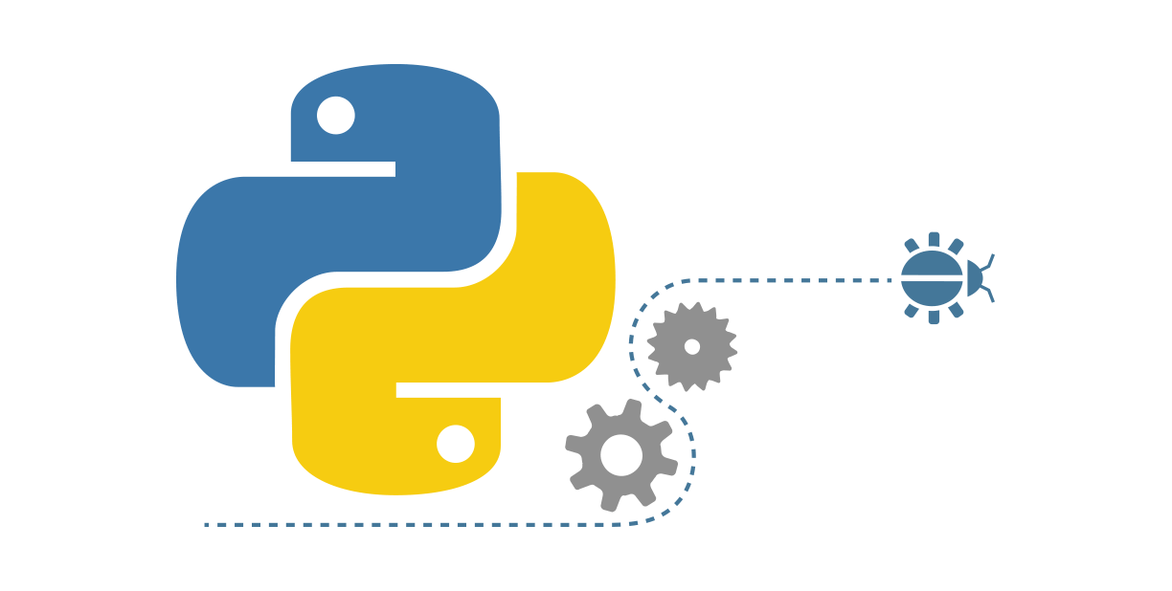

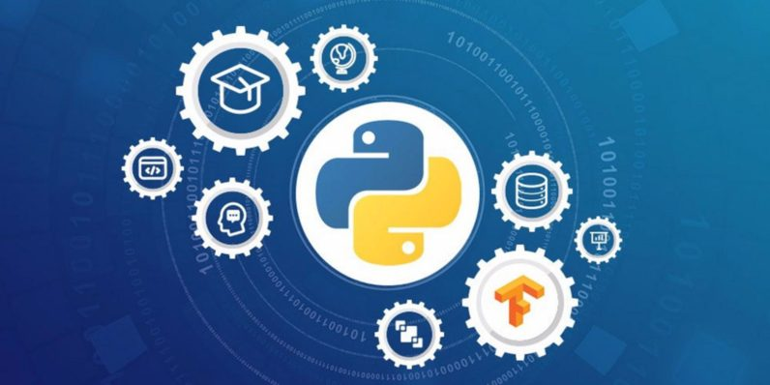

CT-175 – Programming Fundamentals

Lab Manual

FALL 2019

Department of Software Engineering

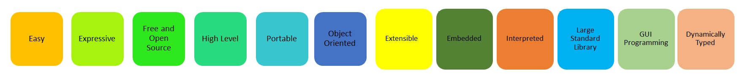

Roll No: Student Name:



Section: _____________ Semester: ___________

Instructor Name: Engr.Asma Khan

Lab No: Dated: